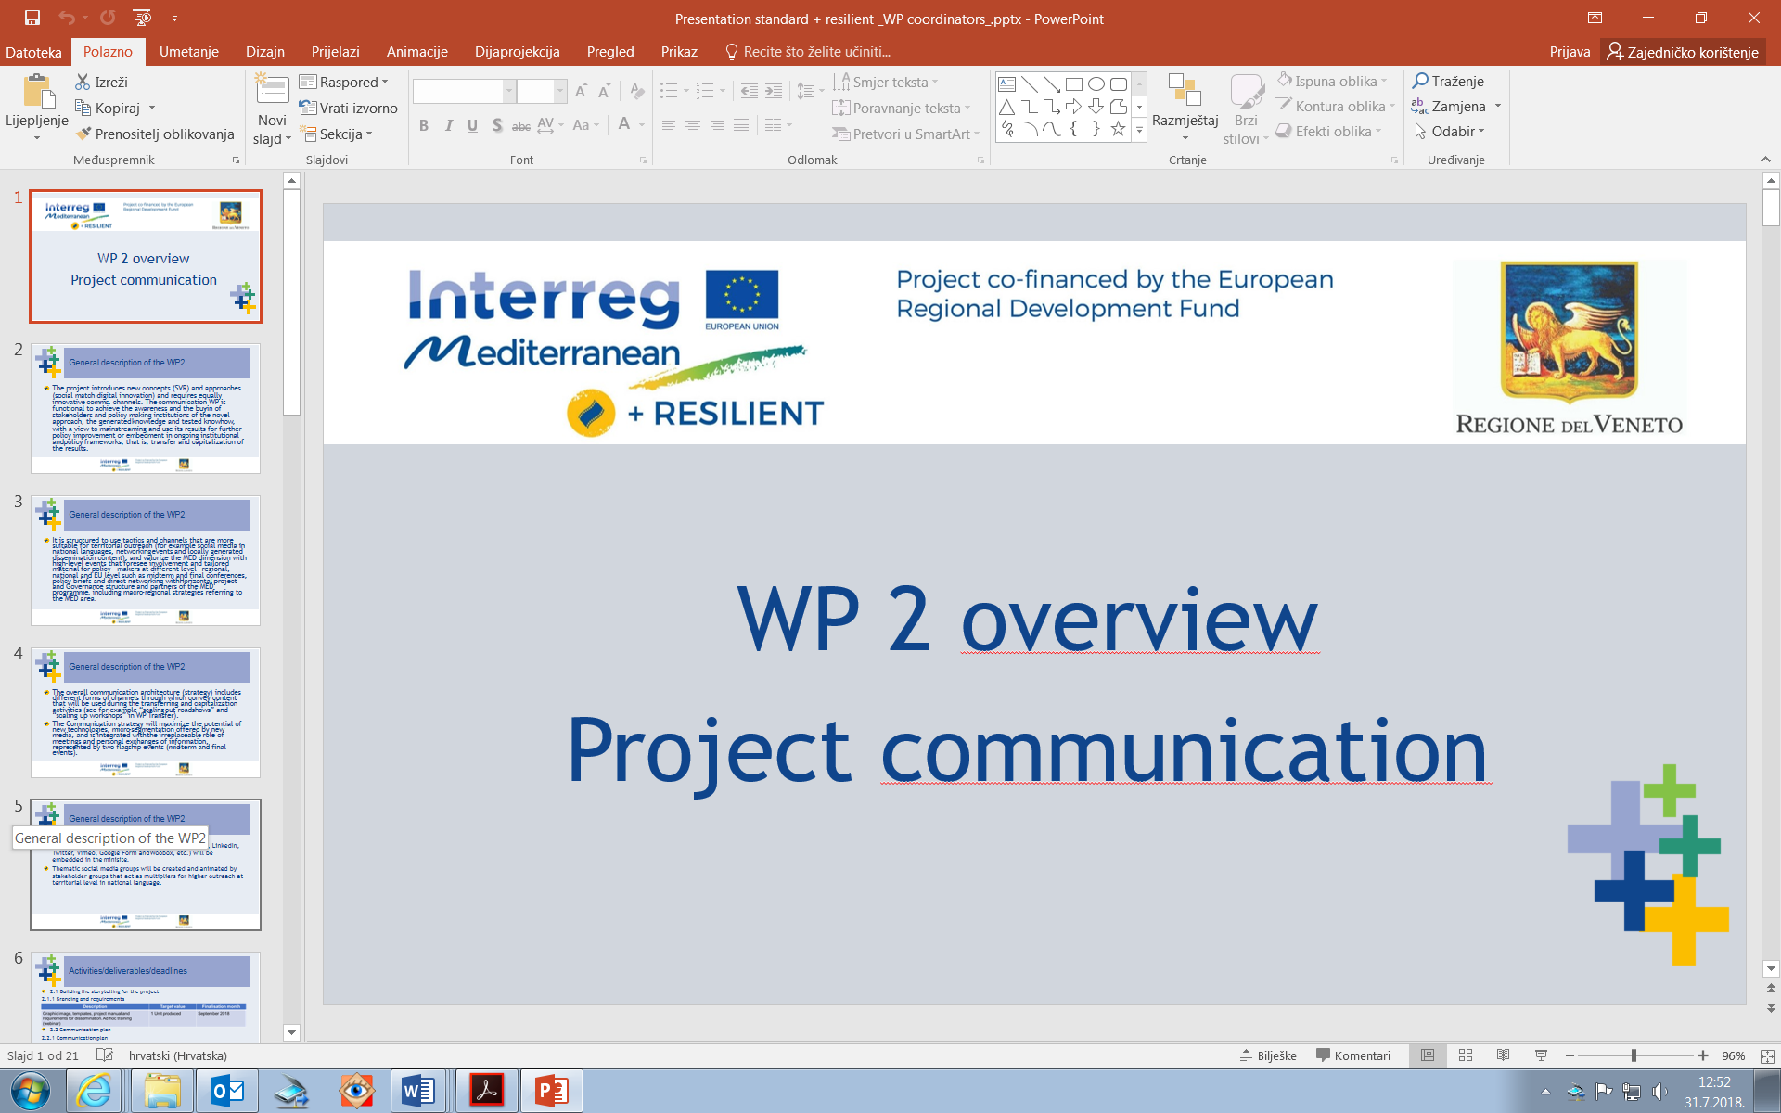

+RESILIENT- Mediterranean Open REsouRcEs for Social Innovation of SociaLly ResponsIve ENTerprises

Ideation tools and techniques for public service design and social innovation Webinar Agenda

Regione del Veneto

+ RESILIENT 2nd Webinar

Ideation tools and techniques for public service design and social innovation

DECEMBER 18TH 2020 10:00 – 13:30 CET

**Introduction and objectives of the webinar**

How can we foster truly innovative and sustainable solutions for the well-being of our citizens and enterprises? What can be done to involve the movers and the shakers to make innovative solutuons work? And how can we do it at the times of social distancing and digitalization? If you want to get some answers to these questions join the + RESILIENT webinar on December 18th, 2020.

The aim of this webinar is to share some basic approaches and methods for social innovation development within the framework of „co-design“.

It is addressed to the +RESILIENT partners and the MED Community interested in co-creation of social innovation that addresses challenges that are not currently tackled adequately, with a participatory and integrated approach.

It helps the + RESILIENT partners to mobilize and involve stakeholders for their pilot action, transfer and capitalization, but more in general stakeholders in the MED area to work on integrated and sustainable development and social cohesion. It includes methods of Service Design, Action planning, Design thinking to mention a few approaches.

The webinar will be in itself an exercise of participatory work (with tips to adapt such processes to the virtual environment), participants should be ready to actively contribute to the webinar.

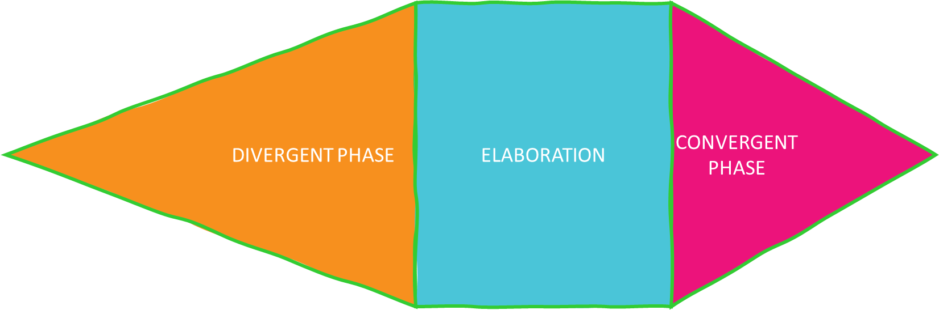

The webinar is open, but registration is required.

Please [register here](https://forms.gle/sHh3gJ7BBXaqxEDU6) by December 14, 2020 at latest. Information will be sent to registered participants.

**DRAFT AGENDA**

|  |  |
| --- | --- |
| 10.00 | Welcome greetings and general issues – VENETO REGION  INTRODUCTION  Making sense of participatory approaches for social innovation  The divergent phase: tools and methods to create knowledge base, collect ideas and reflect |
| 11.30 | EAT, WALK, REST! END OF PART 1 AND BREAK |
| 12:00 | The convergence phase: assessing, prioritizing and planning for social innovation |
| 13:30 | Q+A END OF PART 2 |